

Name: Divyaben Patel

Assignment topic: Performance Testing

Student ID: 8790652

Date: 23rd march 2022

Assignment: 3

**Overview:**

In the below screenshots, Thread Group create real-time request to the server. Here, the number of threads (Users) is set to 1, 2, 3, 4, 5, 10, 15, 20, 25, and 50, so the JMeter will create user request as per number of threads given to the server under test. HTTP request has been sent to a localhost server via HTTP Request sampler. Also we can view summary report of the test, and based on requests from number of users, we can view CPU and Memory utilization Graph in Perfmon Matric Collector under HTTP Request sampler.

**1) Summary Report, CPU and Memory usage analysis for 1 user with loop count 10,000**

**-> Thread Group**

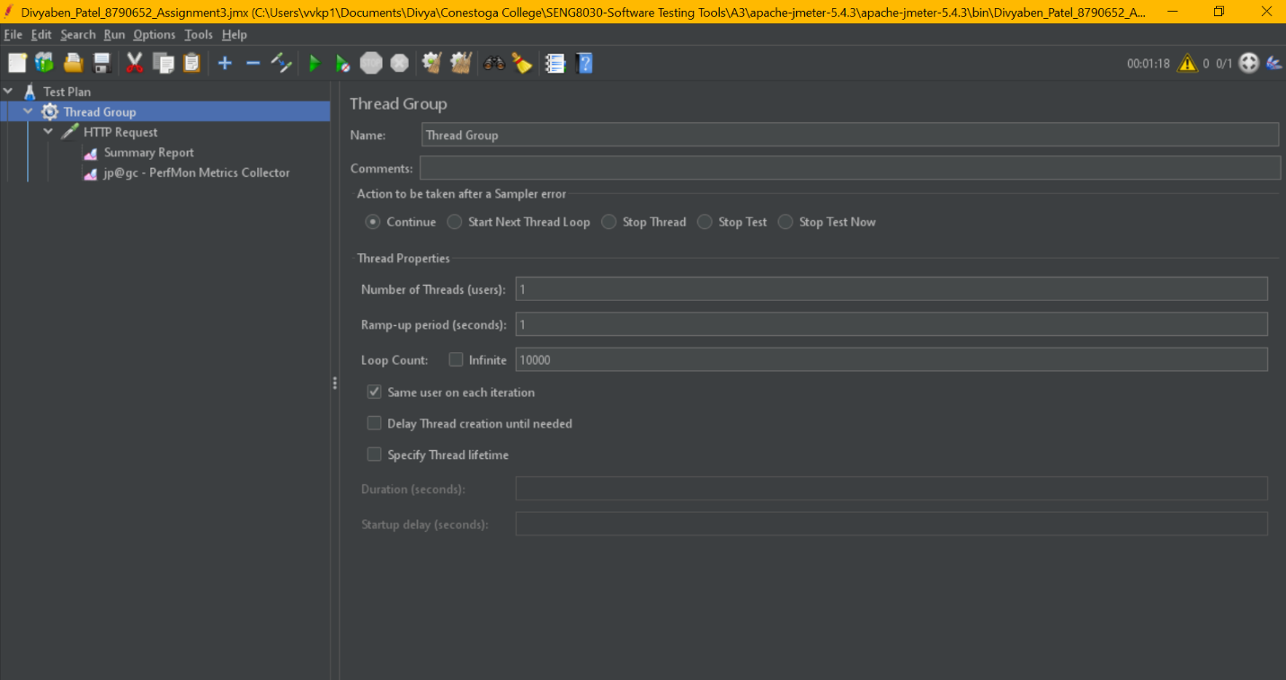

**->**Thread Group > HTTP Request > **Summary Report**

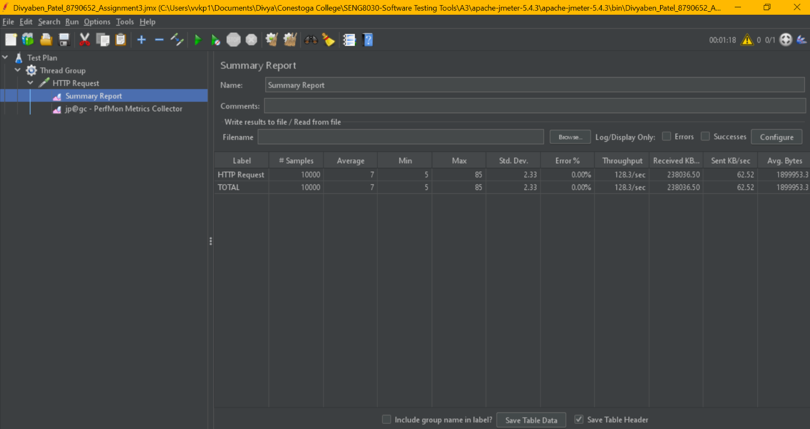

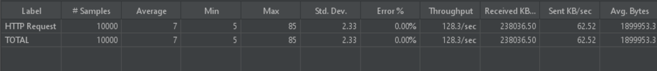

**->** Thread Group > HTTP Request > **Perfmon Metrics Collector**

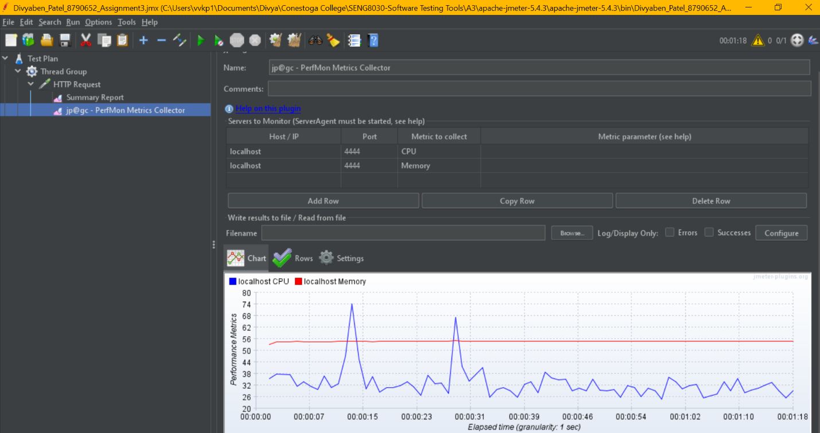

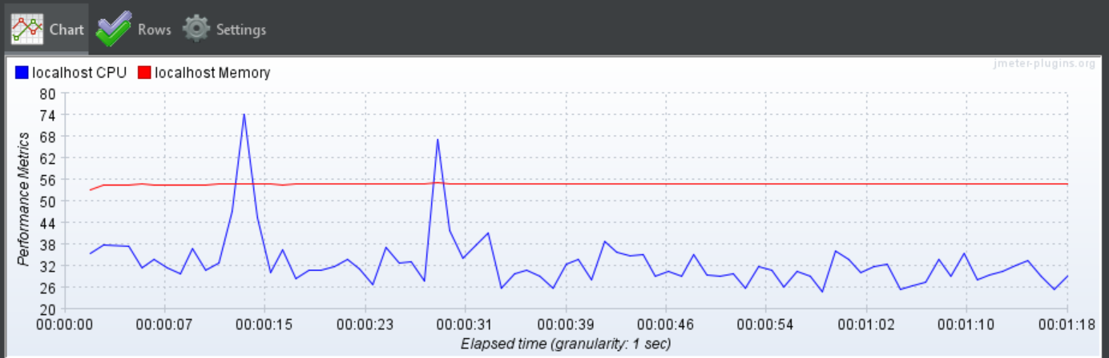

**->**Thread Group > HTTP Request > Perfmon Metrics Collector > **CPU & Memory Utilization**



**->**Thread Group > HTTP Request > Perfmon Metrics Collector > **CPU Utilization**

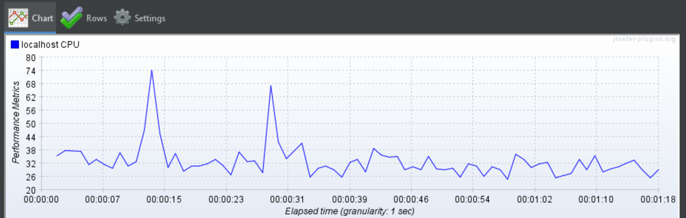

**->**Thread Group > HTTP Request > Perfmon Metrics Collector > **Memory Utilization**

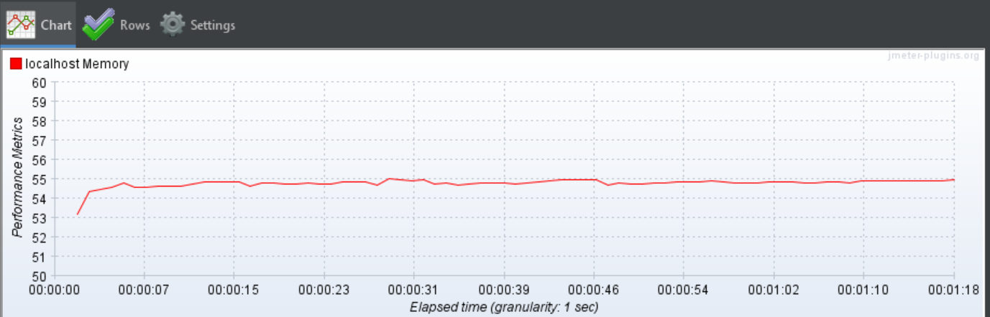

**2) Summary Report, CPU and Memory usage analysis for 2 user with loop count 10,000**

**->Thread Group**

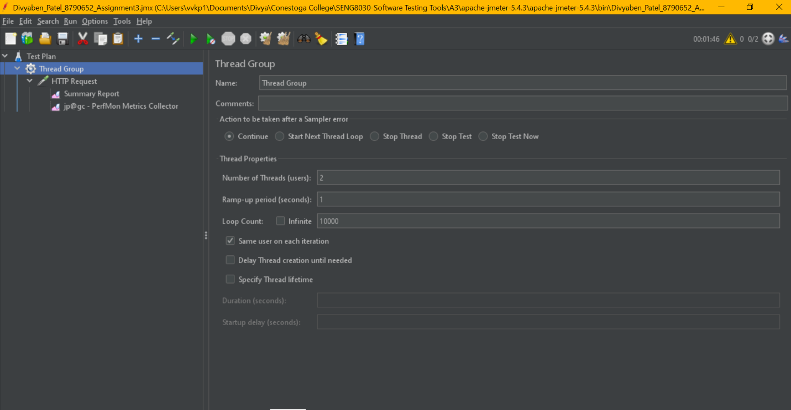

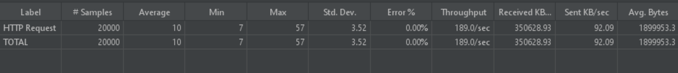

**->**Thread Group > HTTP Request > **Summary Report**

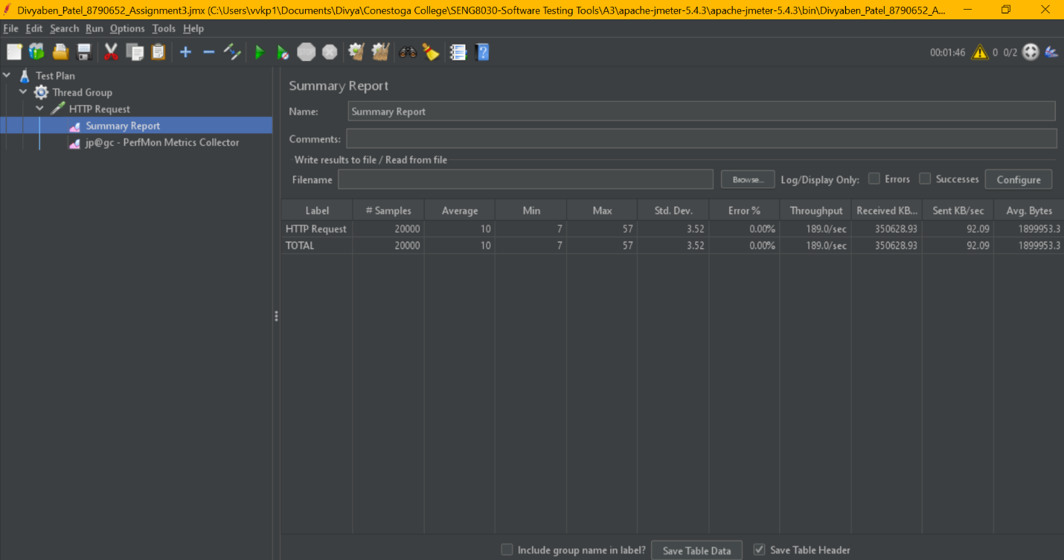

**->**Thread Group > HTTP Request > **Perfmon Metrics Collector**

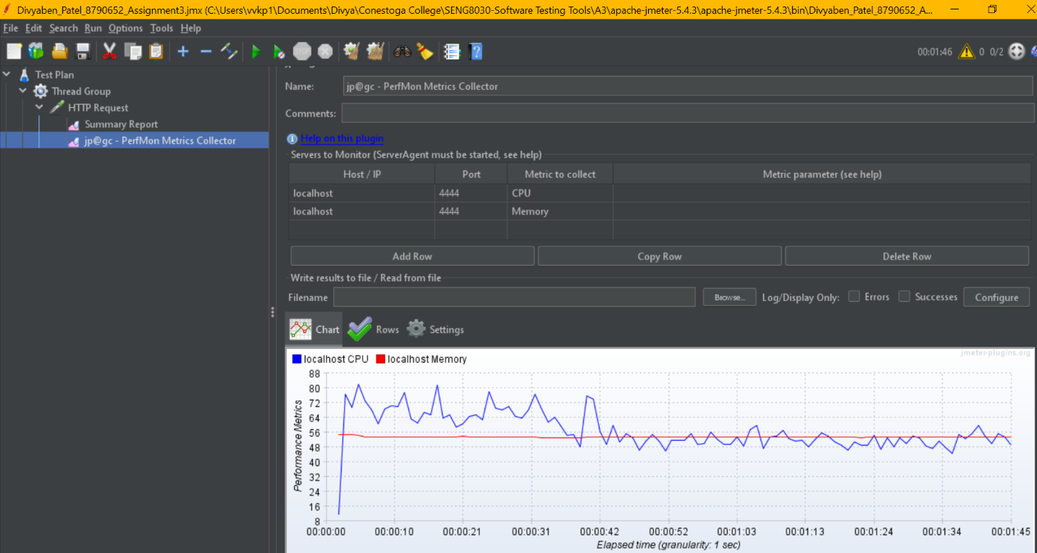

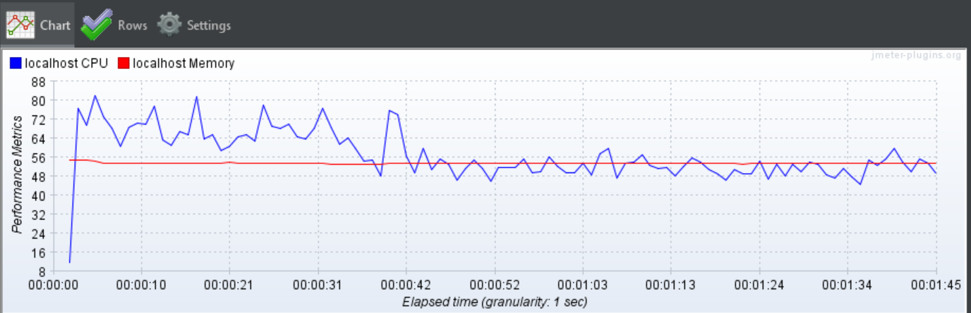

**->**Thread Group > HTTP Request > Perfmon Metrics Collector > **CPU Utilization**

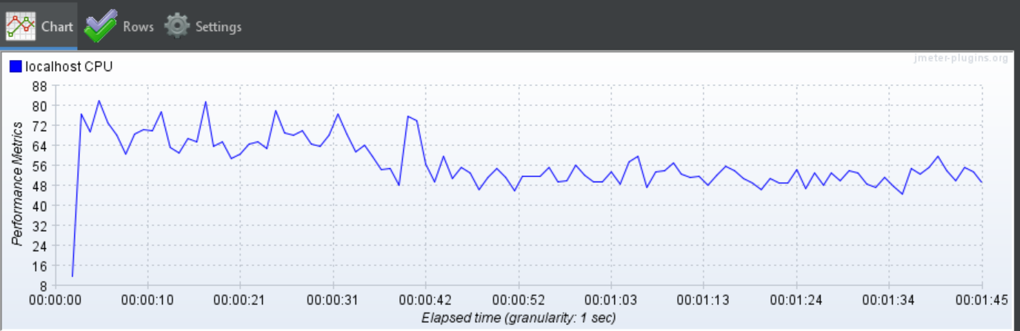

**->**Thread Group > HTTP Request > Perfmon Metrics Collector > **Memory Utilization**

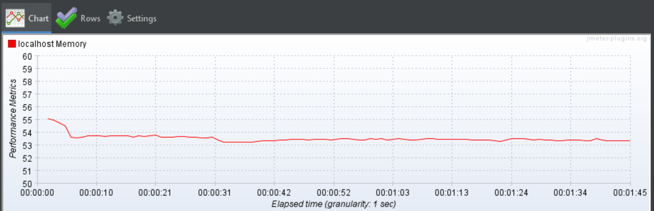

**3) Summary Report, CPU and Memory usage analysis for 3 user with loop count 10,000**

**->Thread Group**

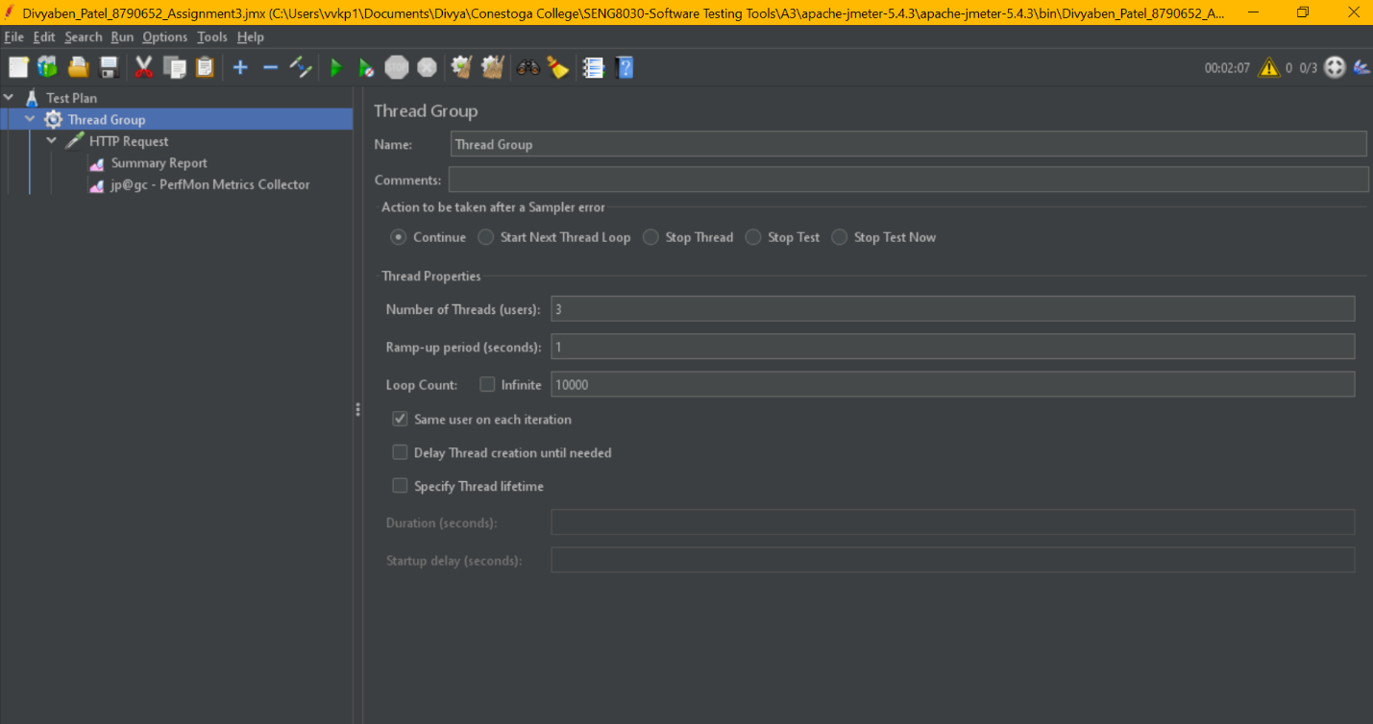

**->**Thread Group > HTTP Request > **Summary Report**

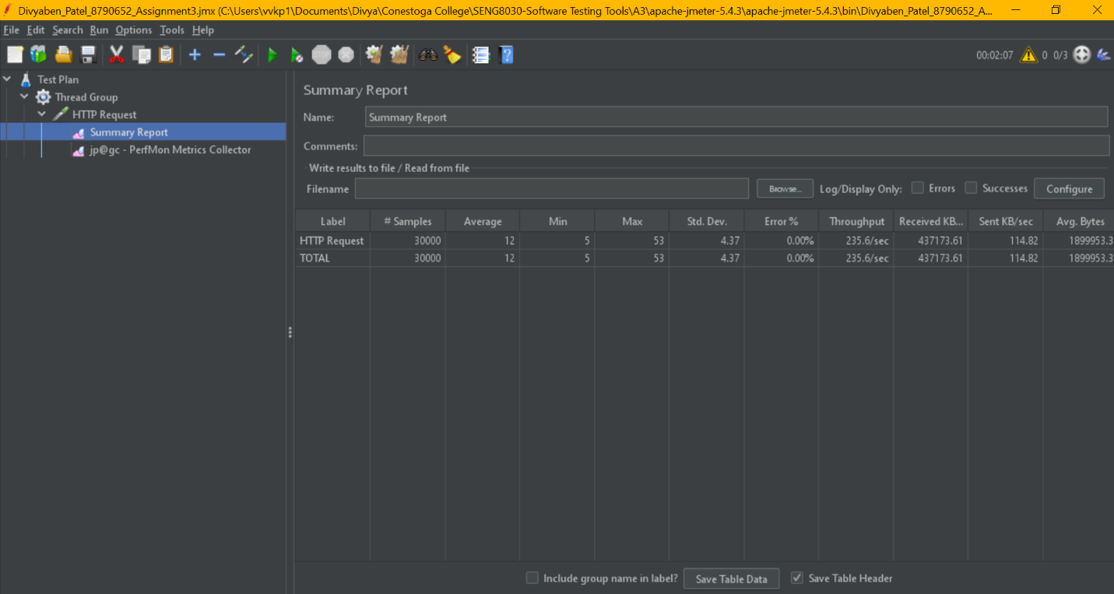

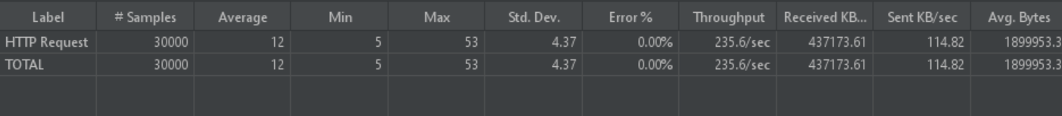

**->**Thread Group > HTTP Request > **Perfmon Metrics Collector**

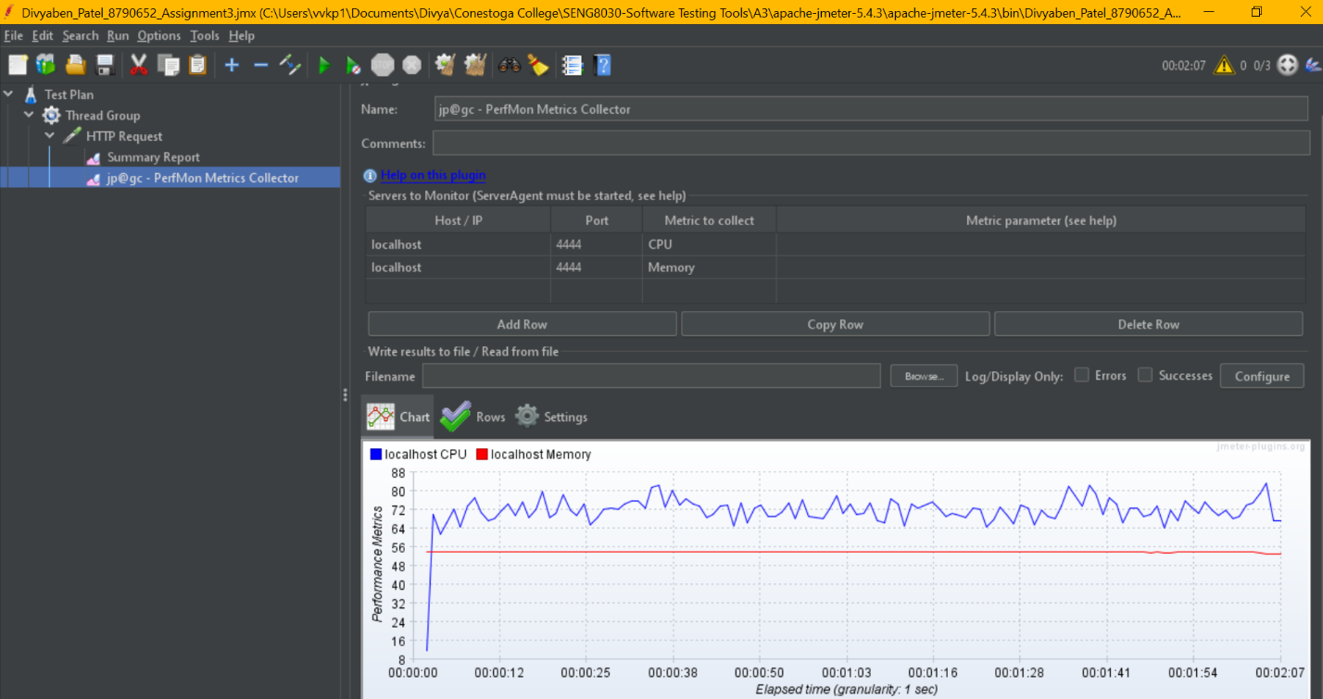

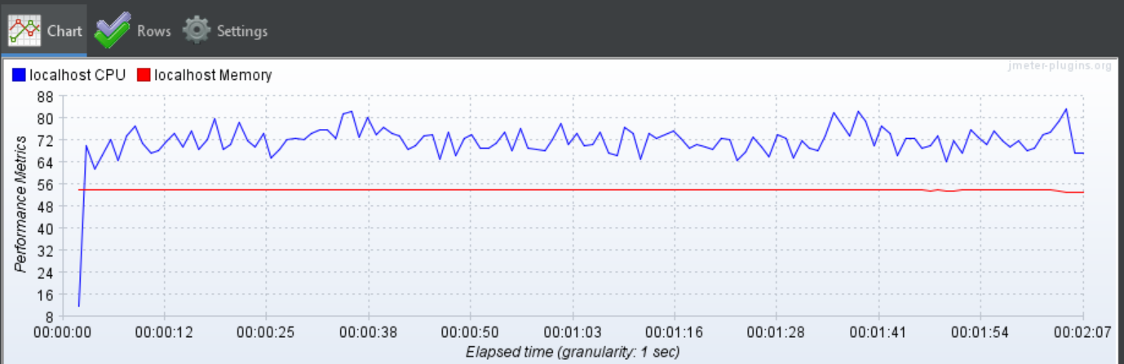

**->**Thread Group > HTTP Request > Perfmon Metrics Collector > **CPU Utilization**

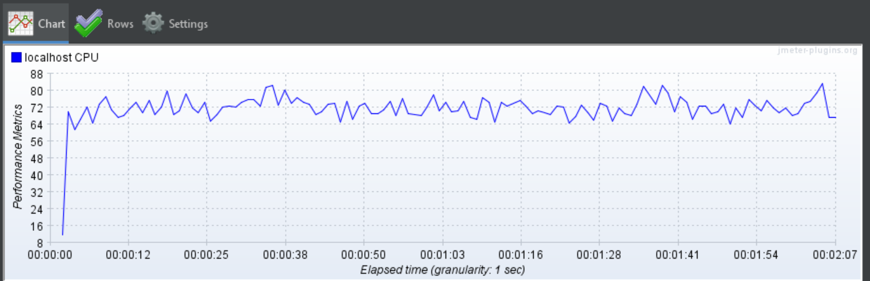

**->**Thread Group > HTTP Request > Perfmon Metrics Collector > **Memory Utilization**

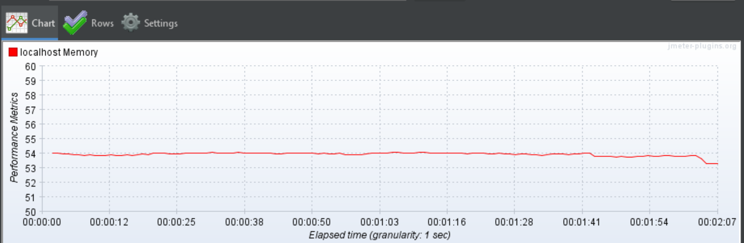

**4) Summary Report, CPU and Memory usage analysis for 4 user with loop count 10,000**

**->Thread Group**

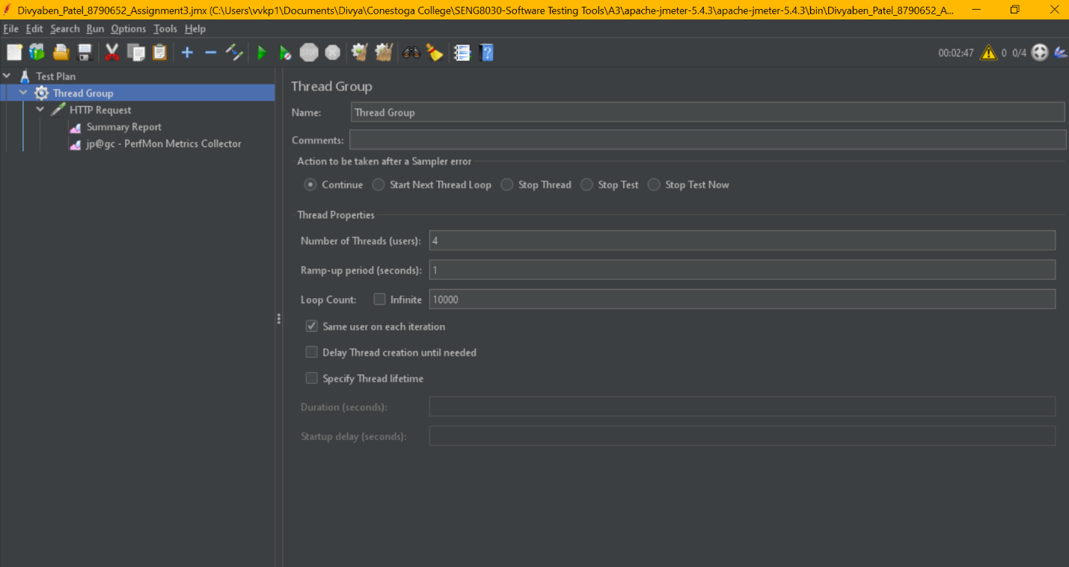

**->**Thread Group > HTTP Request > **Summary Report**

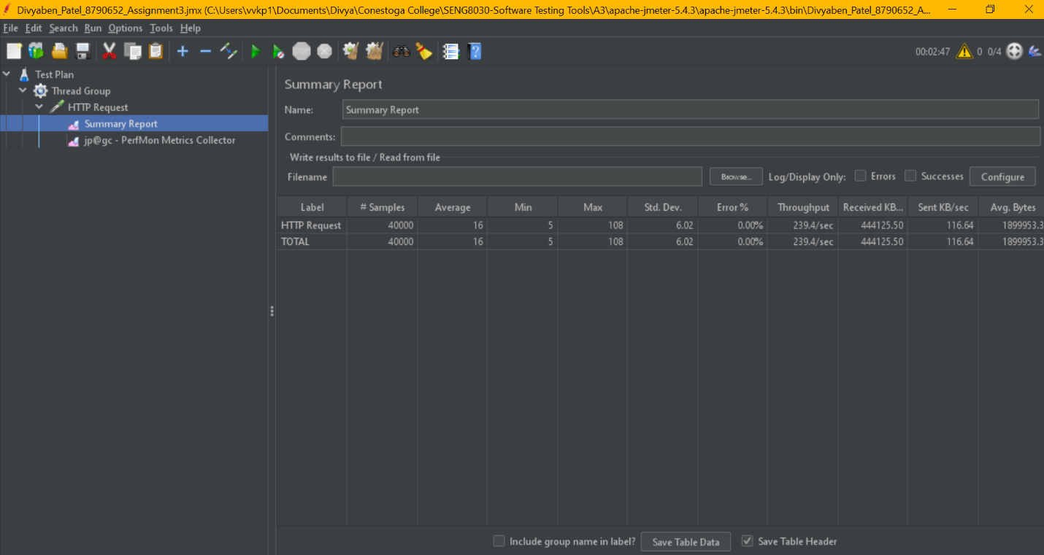

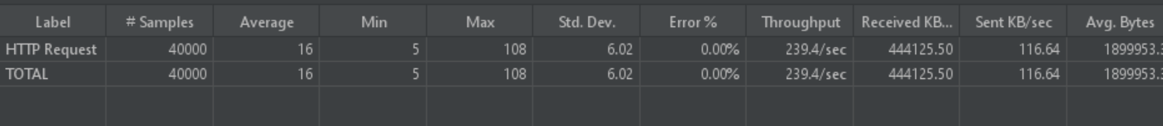

**->**Thread Group > HTTP Request > **Perfmon Metrics Collector**

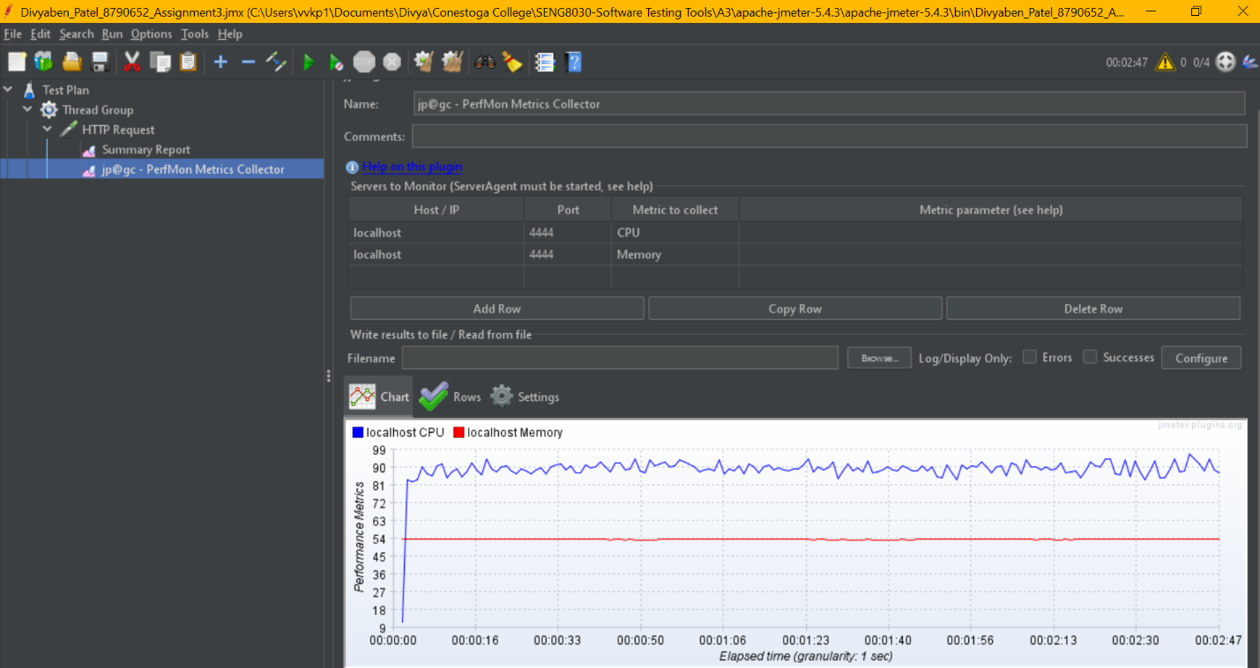

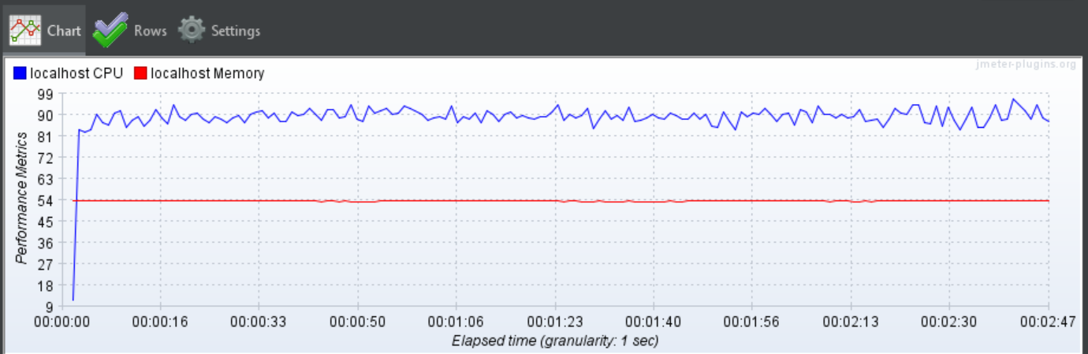

**->**Thread Group > HTTP Request > Perfmon Metrics Collector > **CPU Utilization**

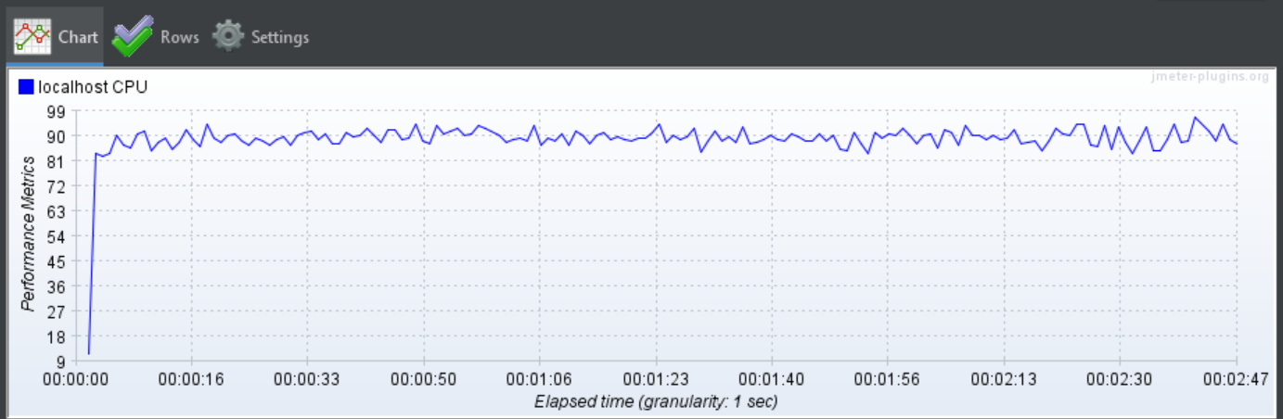

**->**Thread Group > HTTP Request > Perfmon Metrics Collector > **Memory Utilization**

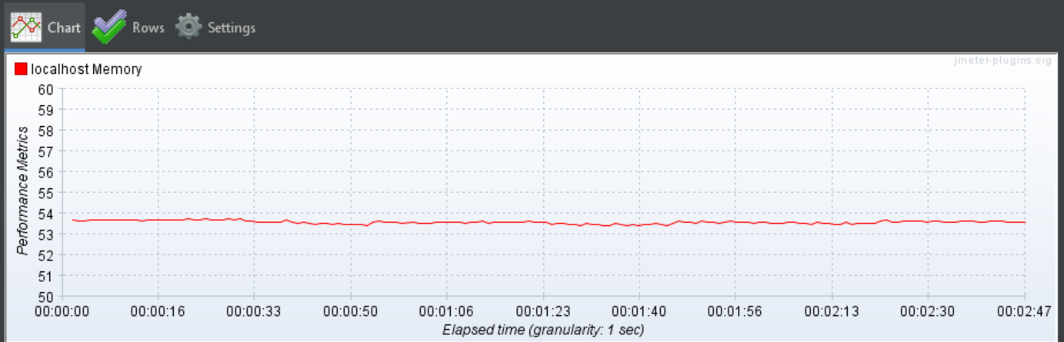

**5) Summary Report, CPU and Memory usage analysis for 5 user with loop count 10,000**

**->Thread Group**

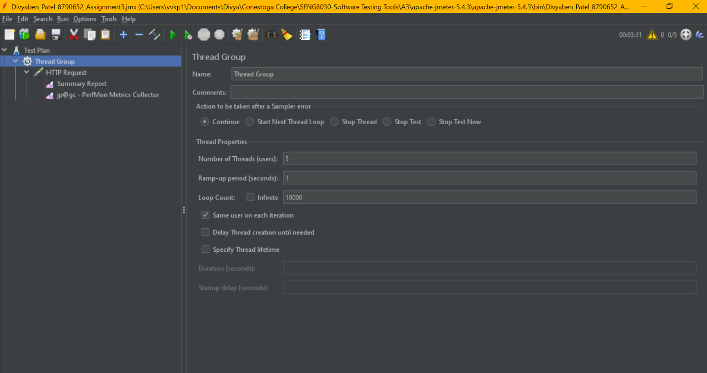

**->**Thread Group > HTTP Request > **Summary Report**

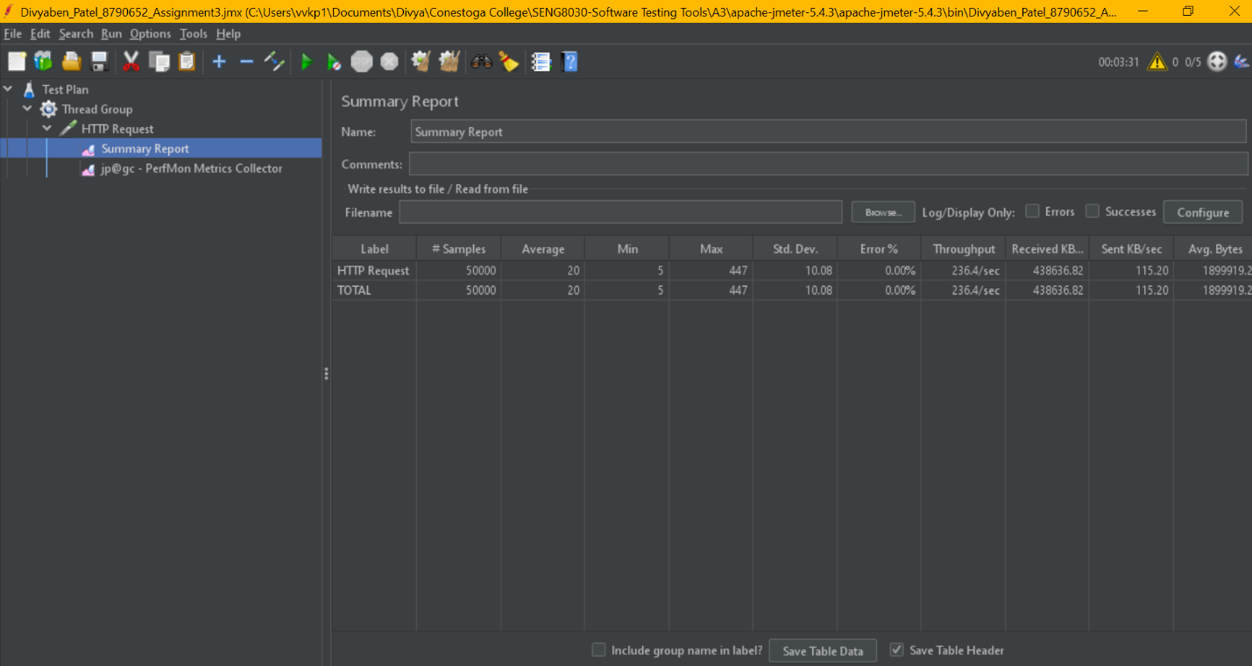

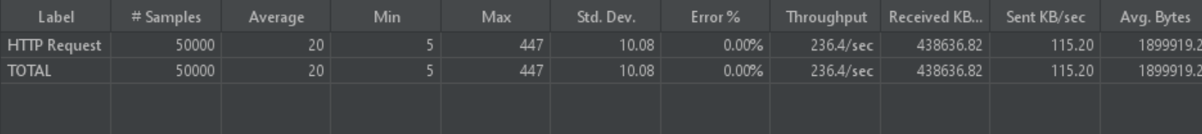

**->**Thread Group > HTTP Request > **Perfmon Metrics Collector**

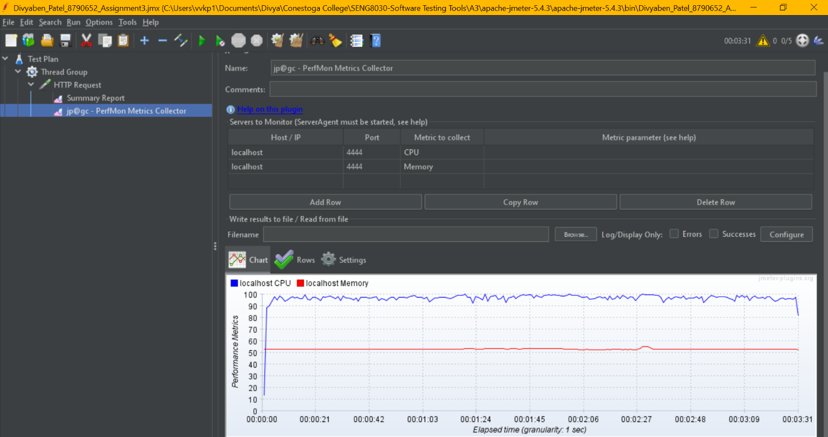

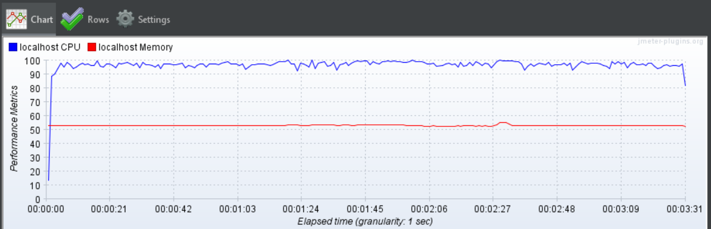

**->**Thread Group > HTTP Request > Perfmon Metrics Collector > **CPU Utilization**

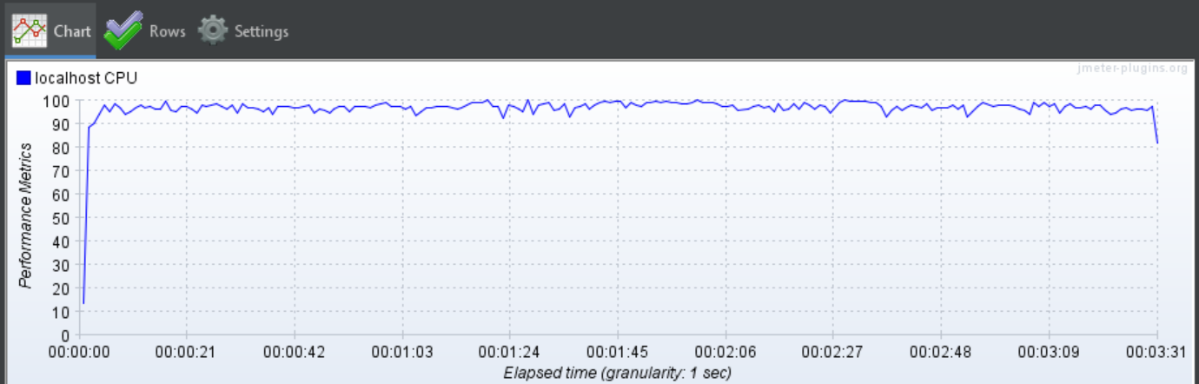

**->**Thread Group > HTTP Request > Perfmon Metrics Collector > **Memory Utilization**

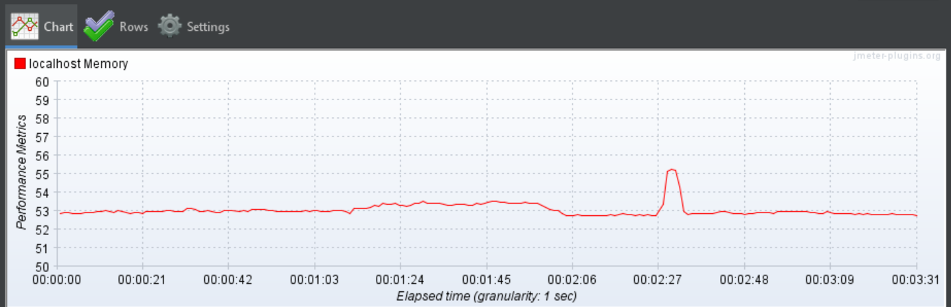

**6) Summary Report, CPU and Memory usage analysis for 10 user with loop count 10,000**

**->Thread Group**

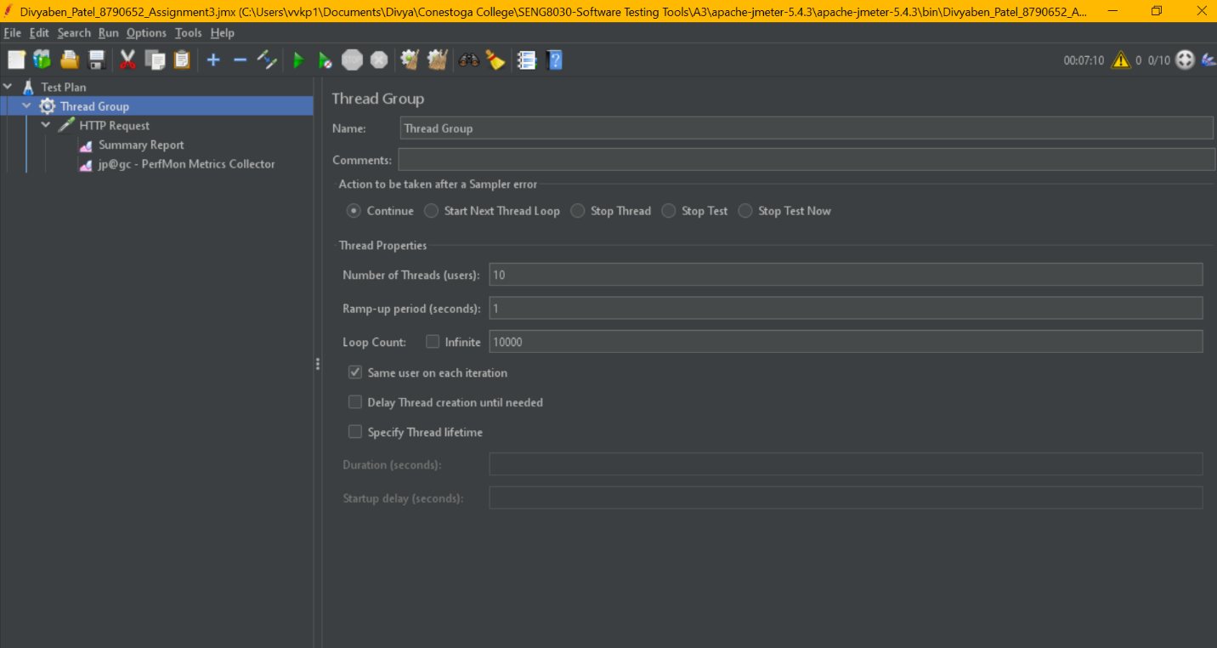

**->**Thread Group > HTTP Request > **Summary Report**

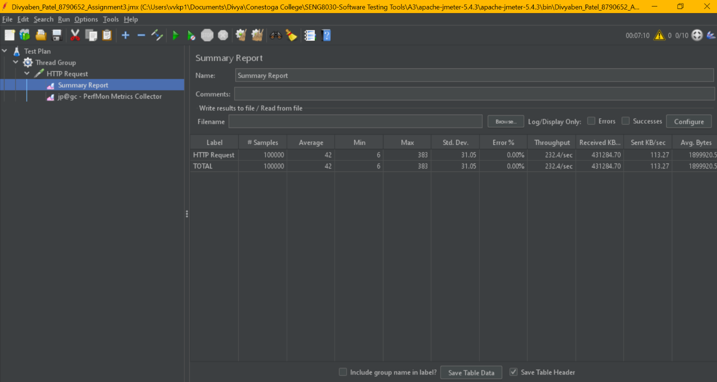

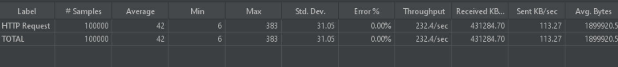

**->**Thread Group > HTTP Request > **Perfmon Metrics Collector**

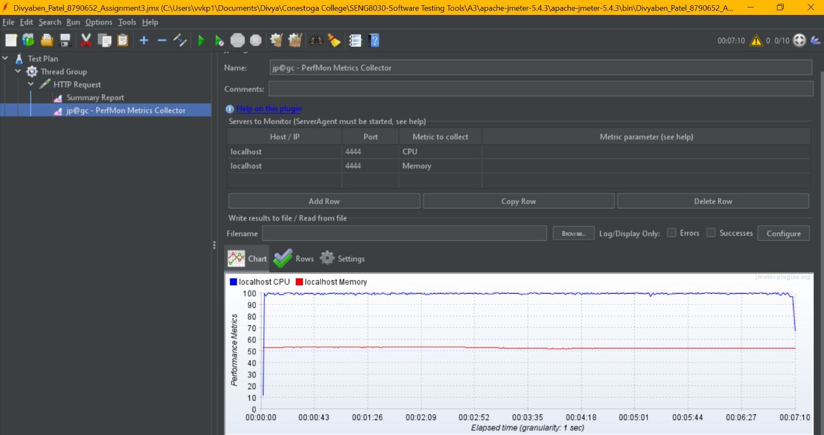

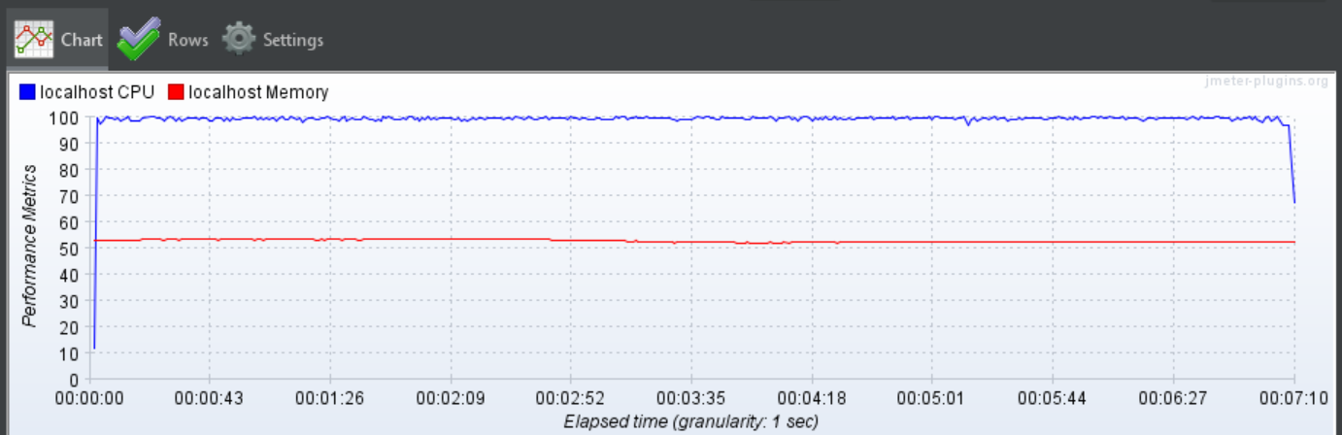

**->**Thread Group > HTTP Request > Perfmon Metrics Collector > **CPU Utilization**

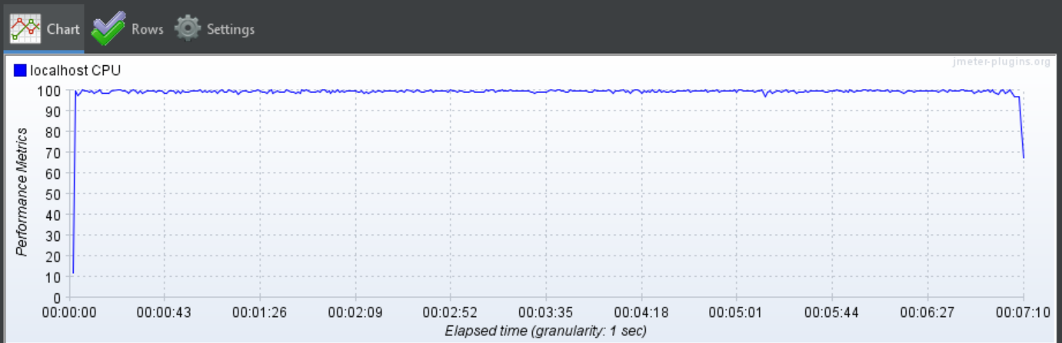

**->**Thread Group > HTTP Request > Perfmon Metrics Collector > **Memory Utilization**

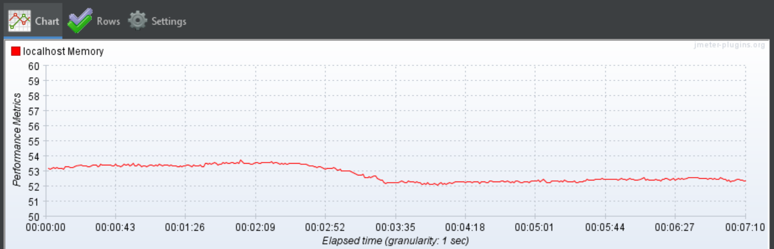

**7) Summary Report, CPU and Memory usage analysis for 15 user with loop count 10,000**

**->Thread Group**

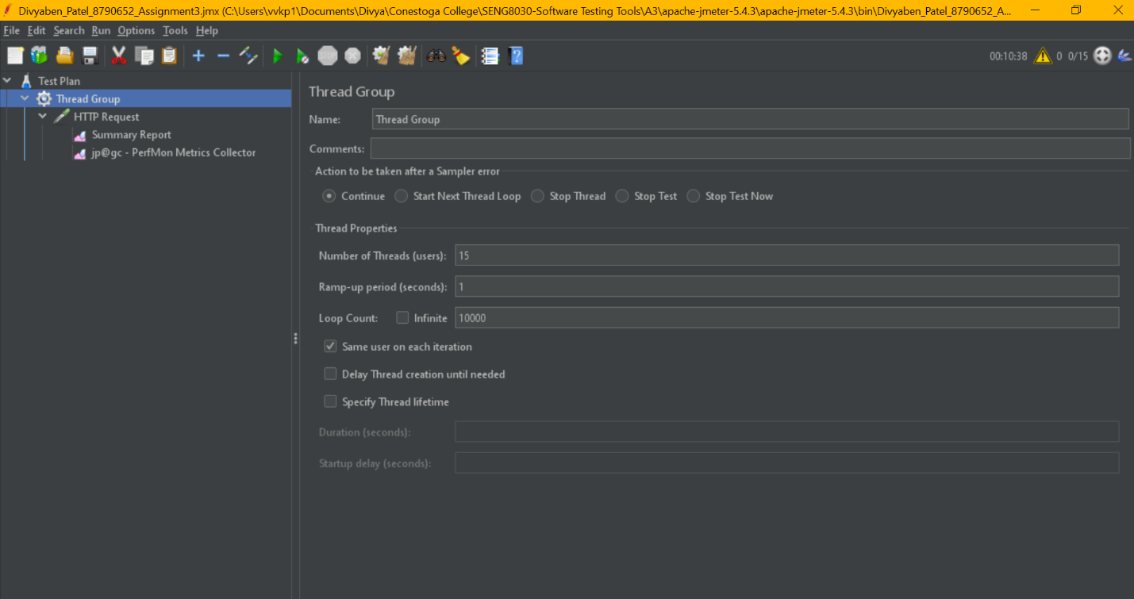

**->**Thread Group > HTTP Request > **Summary Report**

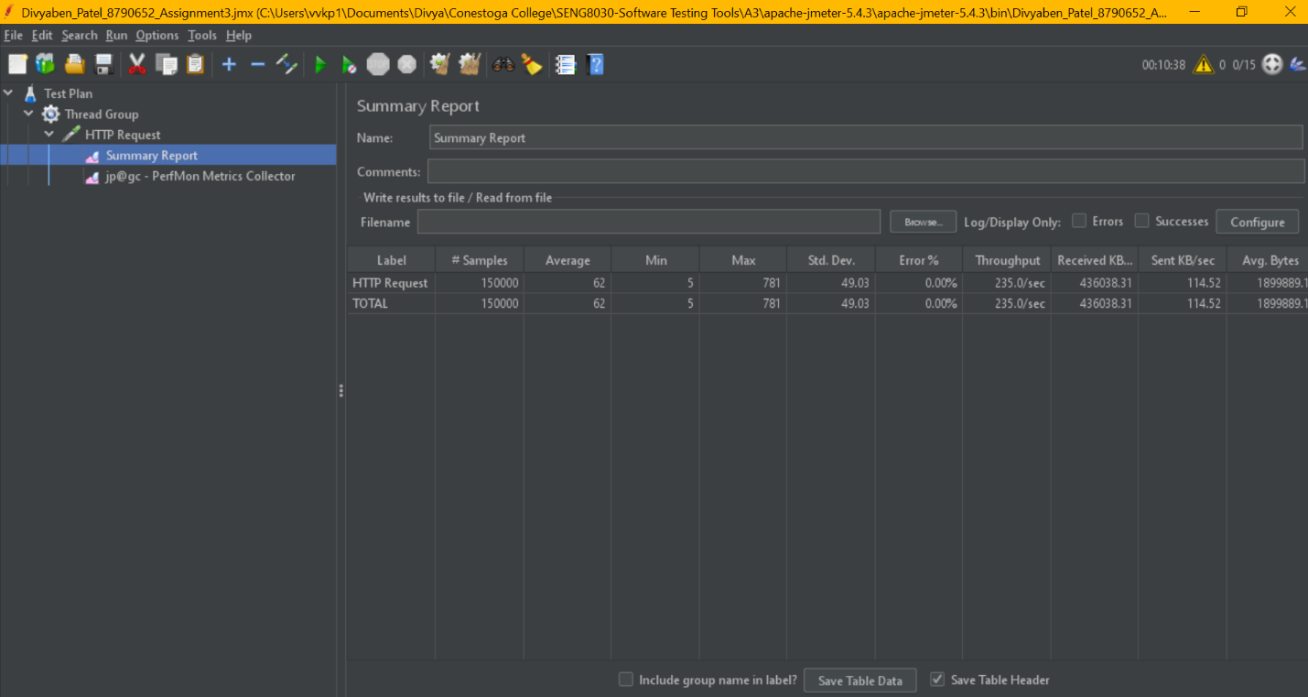

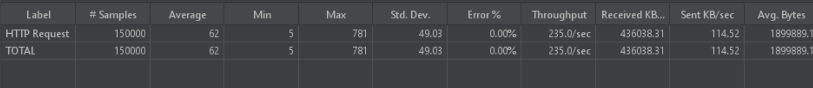

**->**Thread Group > HTTP Request > **Perfmon Metrics Collector**

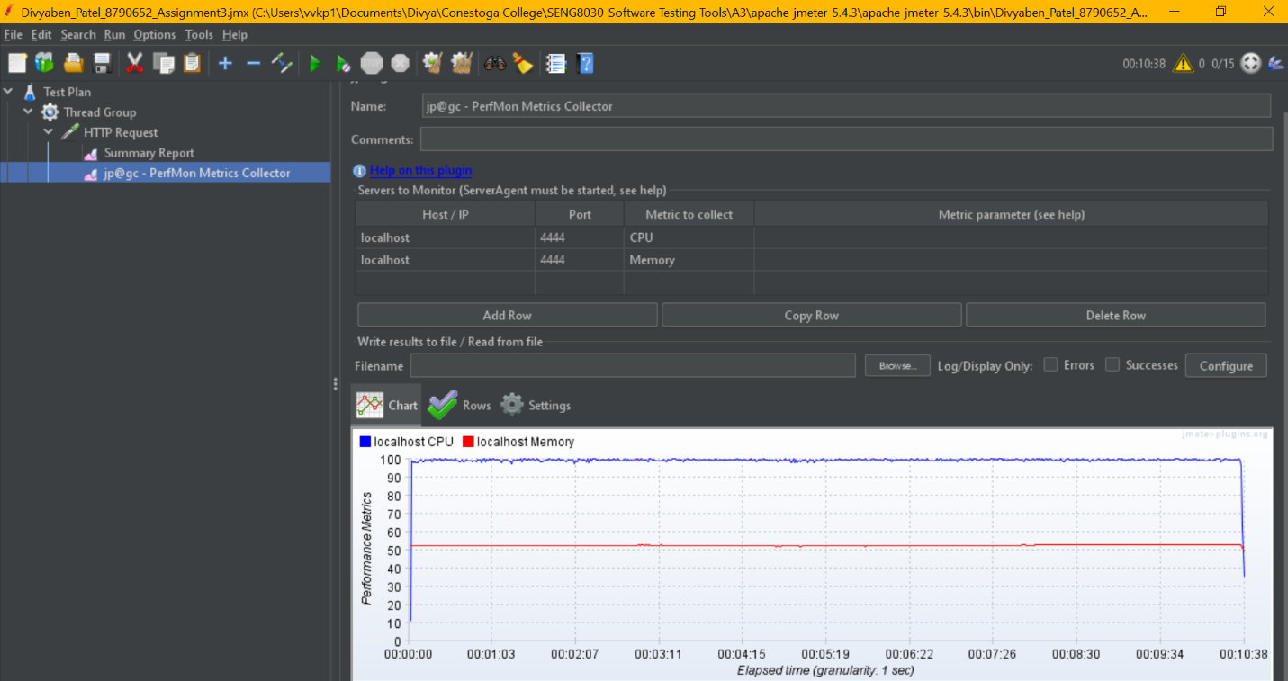

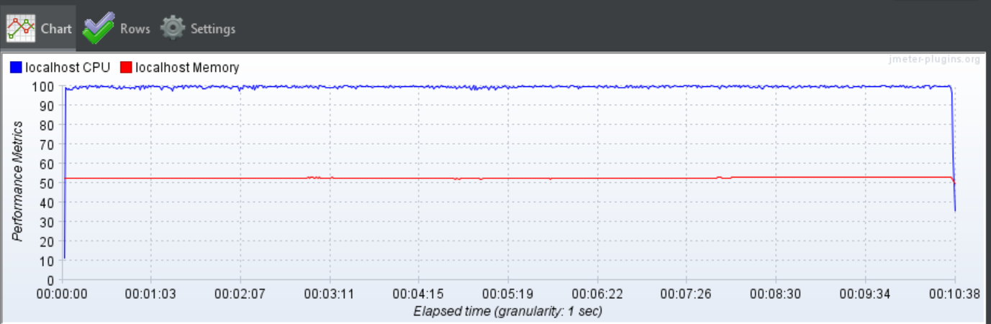

**->**Thread Group > HTTP Request > Perfmon Metrics Collector > **CPU Utilization**

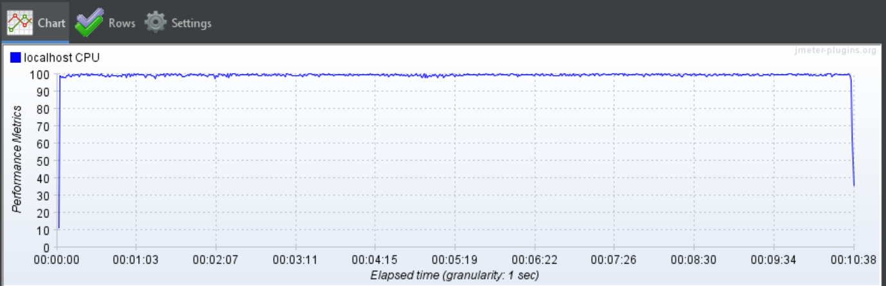

**->**Thread Group > HTTP Request > Perfmon Metrics Collector > **Memory Utilization**

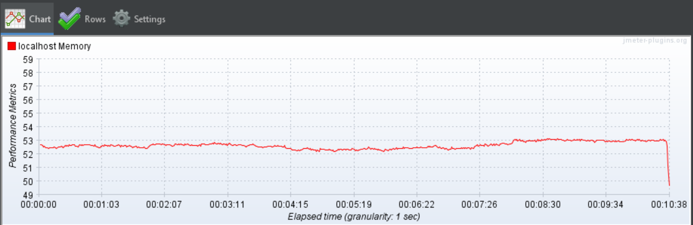

**8) Summary Report, CPU and Memory usage analysis for 20 user with loop count 10,000**

**->Thread Group**

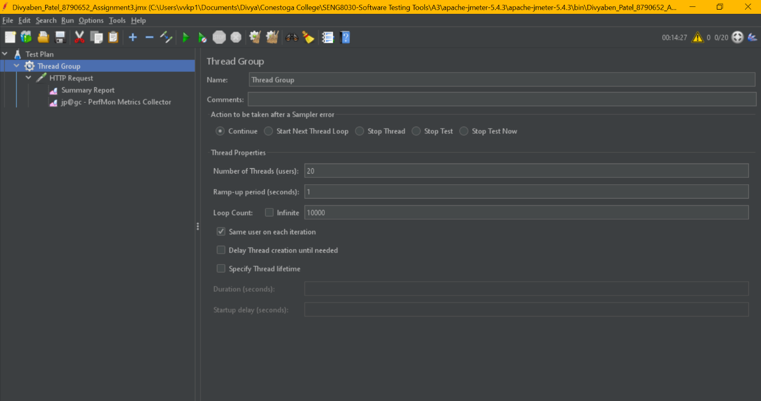

**->**Group > HTTP Request > **Summary Report**

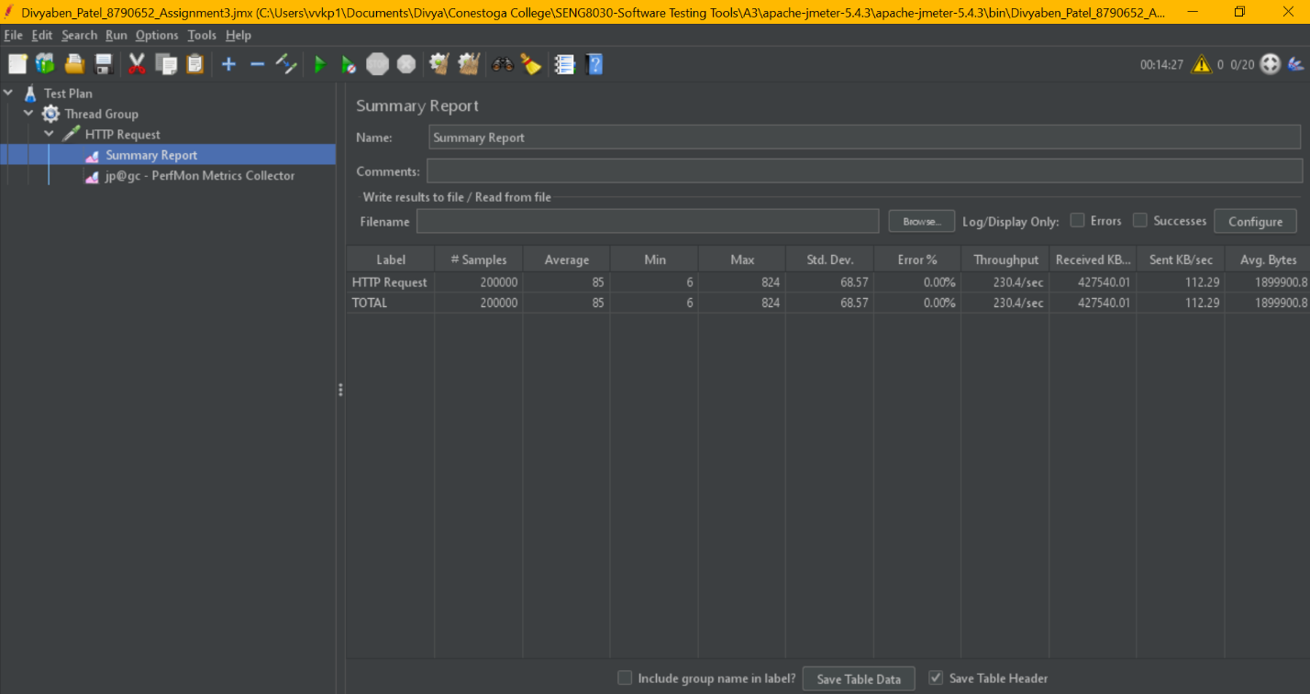

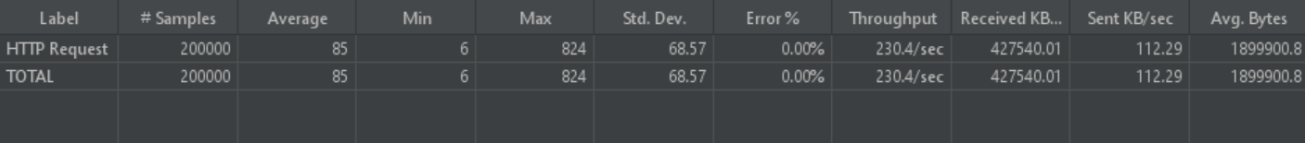

**->**Thread Group > HTTP Request > **Perfmon Metrics Collector**

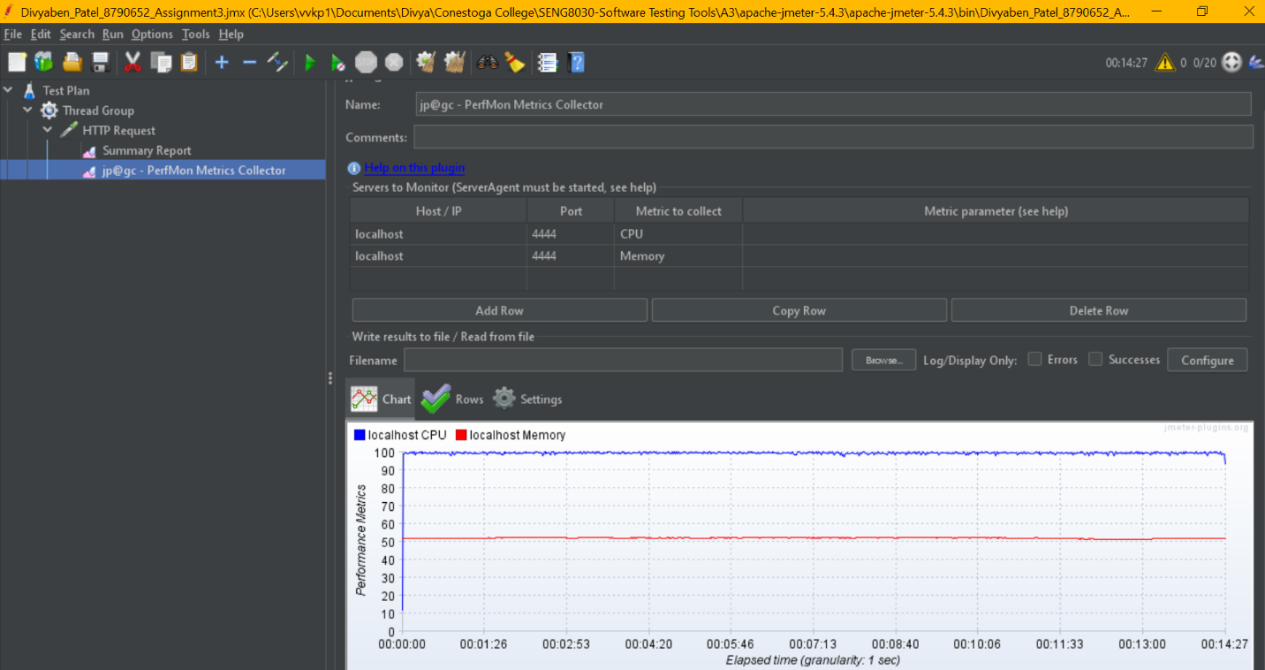

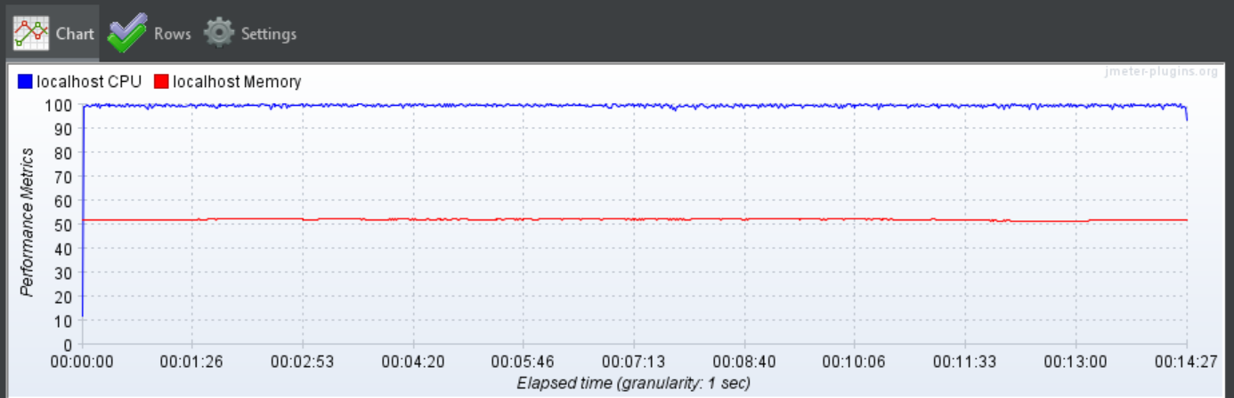

**->**Thread Group > HTTP Request > Perfmon Metrics Collector > **CPU Utilization**

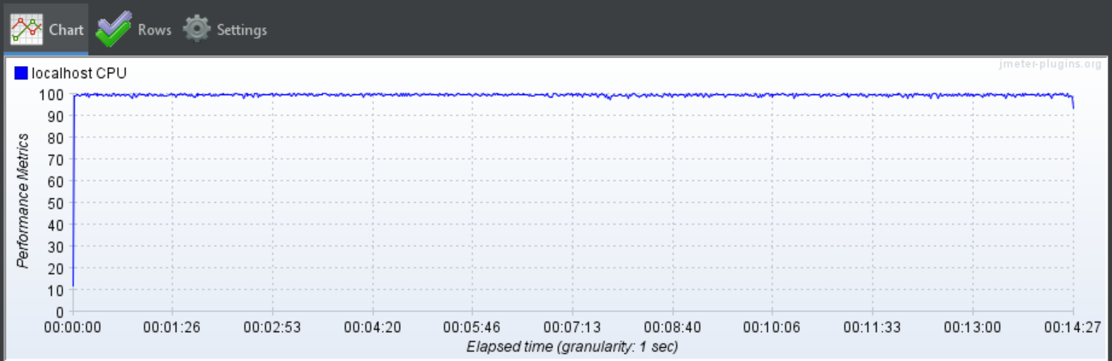

**->**Thread Group > HTTP Request > Perfmon Metrics Collector > **Memory Utilization**

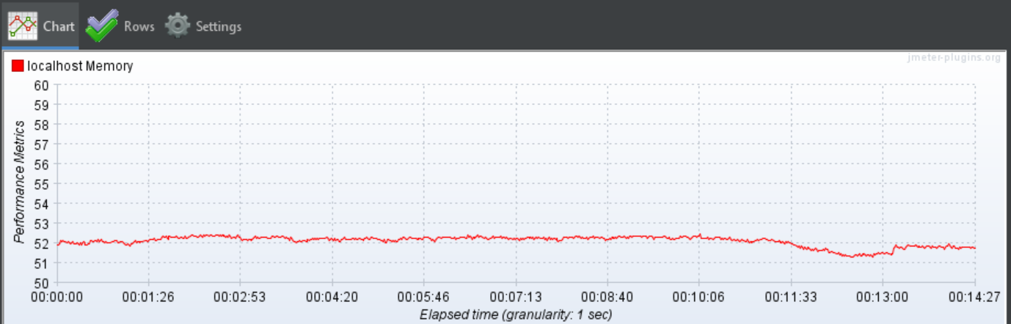

**9) Summary Report, CPU and Memory usage analysis for 25 user with loop count 10,000**

**->Thread Group**

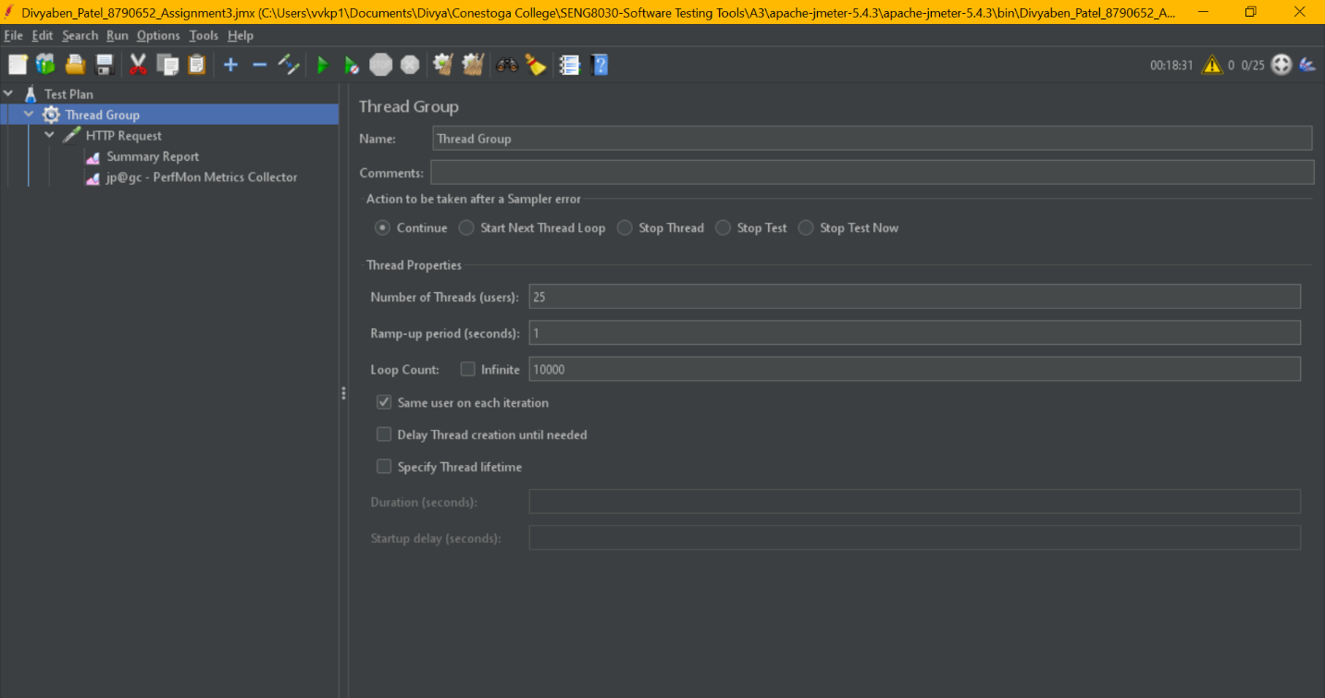

**->**Thread Group > HTTP Request > **Summary Report**

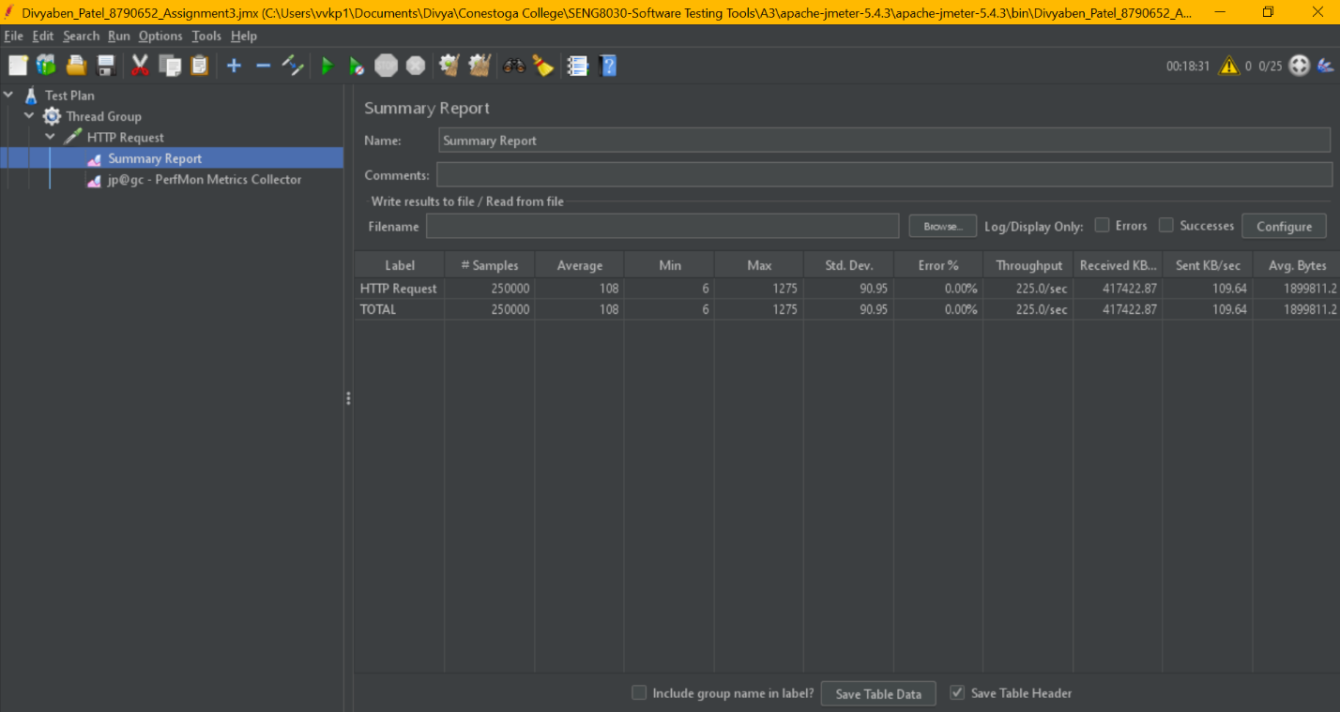

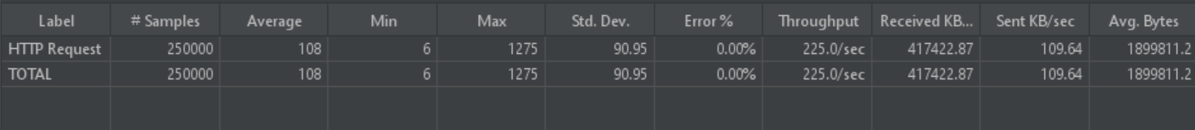

**->**Thread Group > HTTP Request > **Perfmon Metrics Collector**

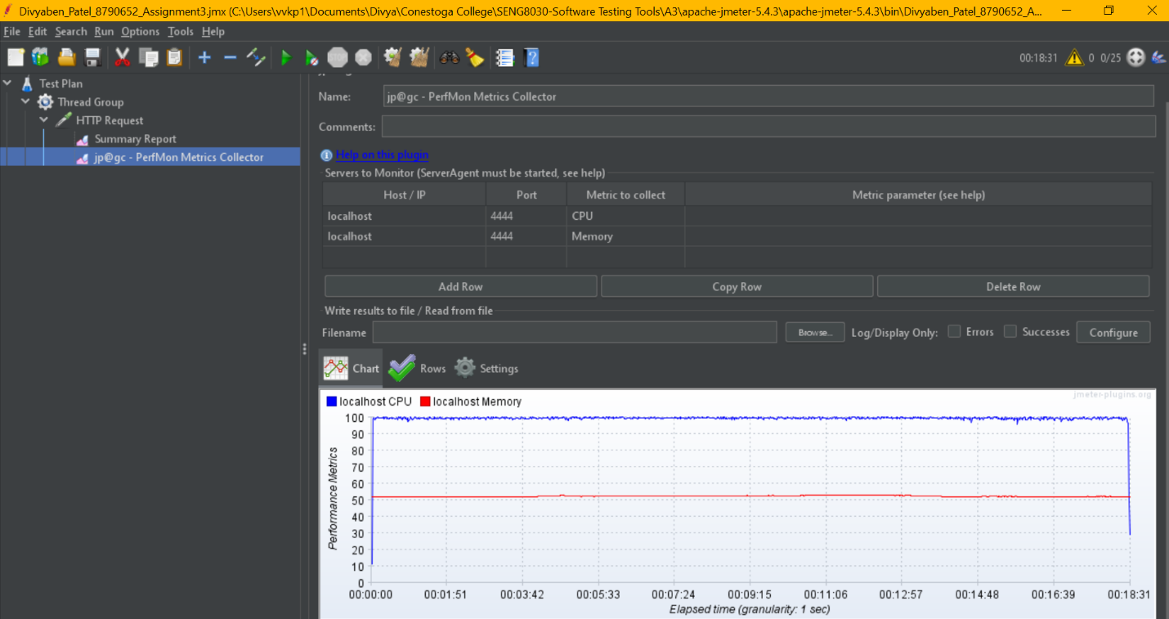

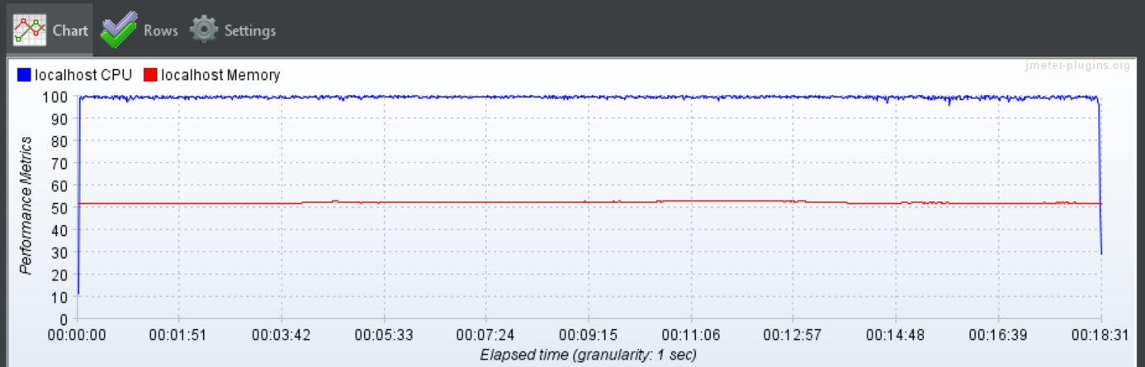

**->**Thread Group > HTTP Request > Perfmon Metrics Collector > **CPU Utilization**

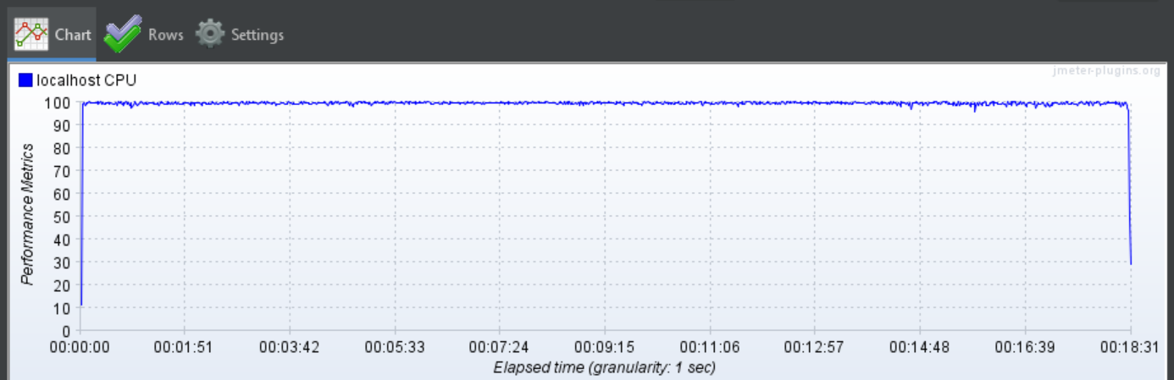

**->**Thread Group > HTTP Request > Perfmon Metrics Collector > **Memory Utilization**

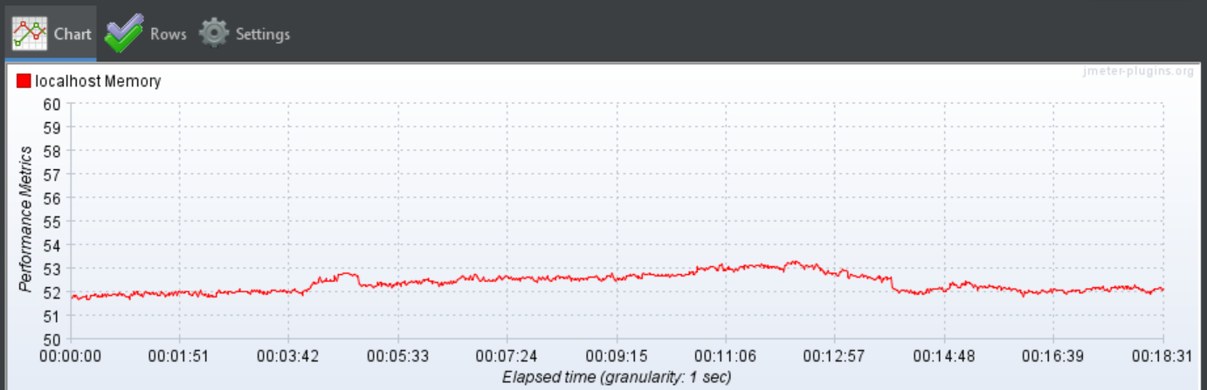

**10) Summary Report, CPU and Memory usage analysis for 50 user with loop count 10,000**

**->Thread Group**

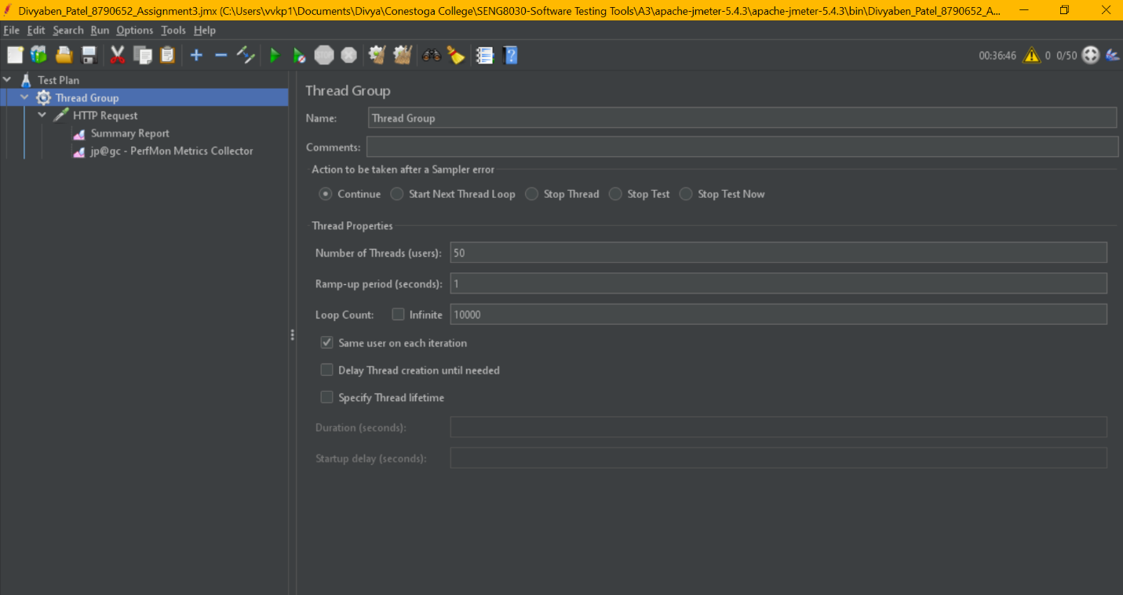

**->**Thread Group > HTTP Request > **Summary Report**

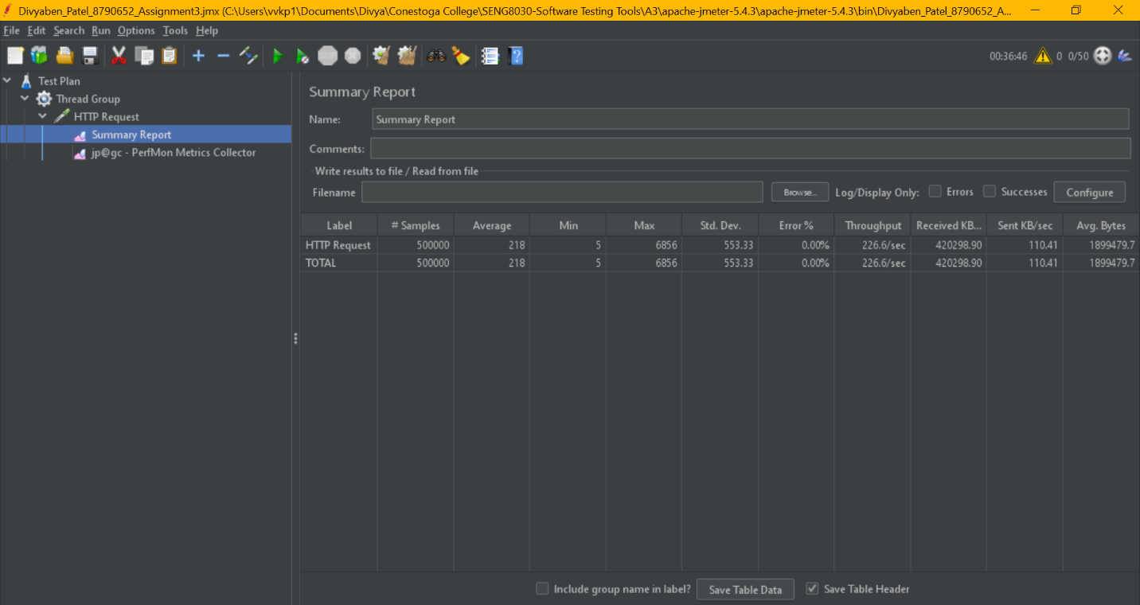

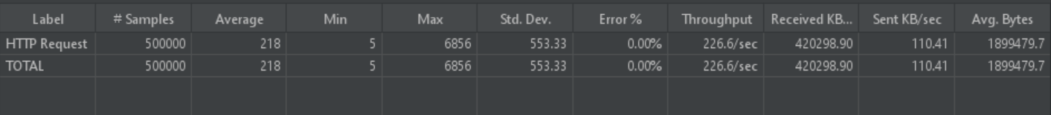

**->**Thread Group > HTTP Request > **Perfmon Metrics Collector**

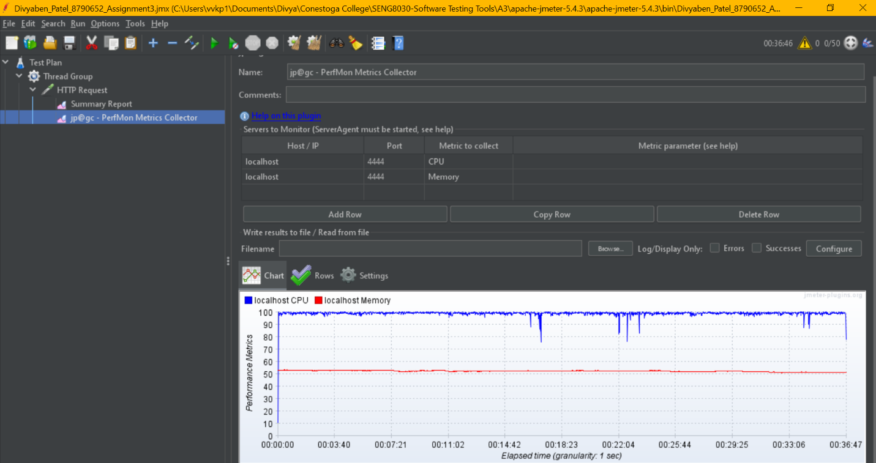

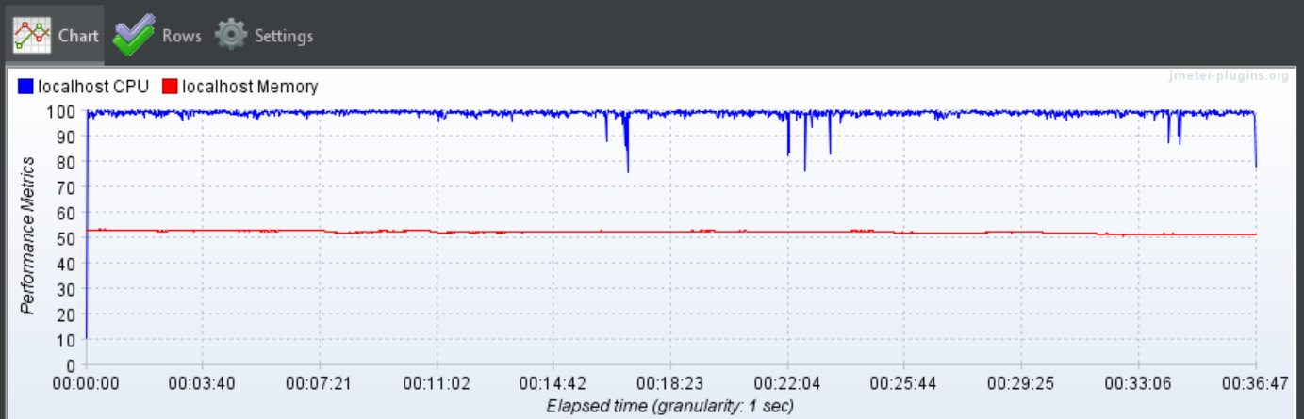

**->**Thread Group > HTTP Request > Perfmon Metrics Collector > **CPU Utilization**

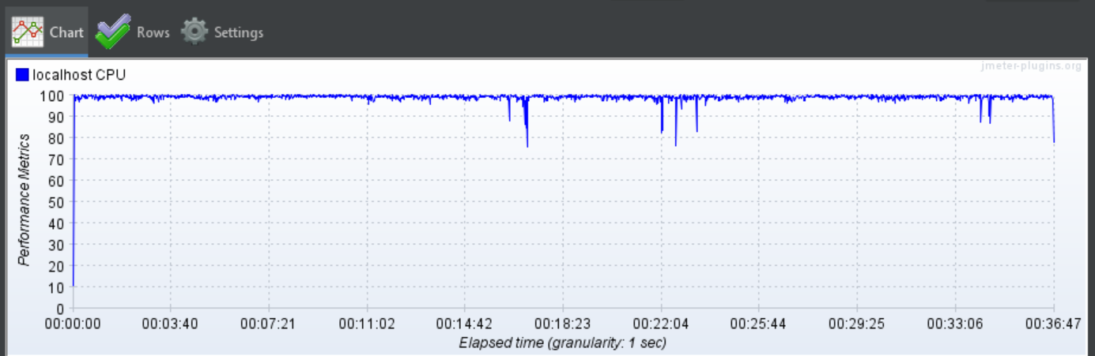

**->**Thread Group > HTTP Request > Perfmon Metrics Collector > **Memory Utilization**

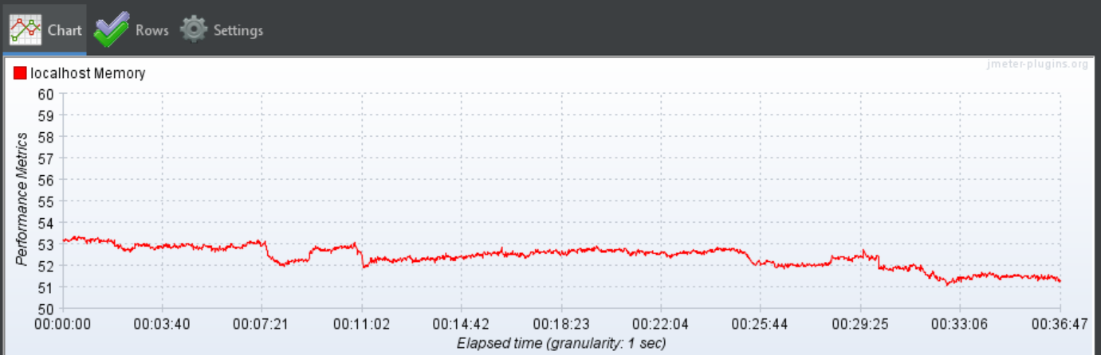

**MS Excel Chart**

|  |  |
| --- | --- |
| **Number of Users** | **Average Response Time** |
| 1 | 7 |
| 2 | 10 |
| 3 | 12 |
| 4 | 16 |
| 5 | 20 |
| 10 | 42 |
| 15 | 62 |
| 20 | 85 |
| 25 | 108 |
| 50 | 218 |

**Explanation**

**Throughput :**

As per summary report table from JMeter shows that, the system can accept no more than 236.4 request per second that is the maximum throughput being able to process in the system. Which means anything more than 236.4 is above the processor limit.

**Average Response Time :**

As per graph in the excel document, we can clearly see that the Average Response Time for webpage increases steadily as the number of users increase. This happens because the system accepts throughput of maximum of 236.4 requests per second. So, when the system receives more requests, then these requests must wait until earlier requests will receive its response. Thus, Response time increases as time required to process these(waiting) requests increases.

**CPU Utilization :**

CPU Utilization graph shows that, performance bottleneck started from and when number of users are 5 or greater. We can see that CPU usage for number of users 4 and 5 is around 80 to 95 percent and then this percentage became 100 when taken number of users are 10, 15, 20, 25 and 50 which means CPU has reached its peak capacity and cannot handle number of users more than 5 simultaneously.

**Memory Utilization :**

Memory Utilization graph shows that the amount of memory used is between 53 to 55 percent when there is maximum of five number of users and the CPU capacity has reached its peak. Later, when CPU Utilization hits its peak of 100% and number of users are more than five, at that time, memory usage dropped to 53 and under.

Overall, Users are the main element that has led this website to performance bottleneck. As we have seen that in throughput that more user requests can slower the process. Mainly, the User request is the factor could affect the performance of the website when it’s released to production.